PIZZA SALES SQL QUERIES

1. **KPI’s**
2. **Total Revenue:**

SELECT SUM(total_price) AS Total_Revenue FROM pizza_sales

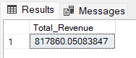

1. **Average Order Value:**

SELECT SUM(total_price)/ COUNT(DISTINCT(order_id)) AS Avg_Order_Value FROM pizza_sales

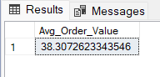

1. **Total Pizza Sold:**

SELECT SUM(quantity) as Total_Pizza_Sold FROM pizza_sales

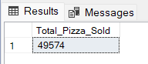

1. **Total Orders:**

SELECT COUNT(DISTINCT(order_id)) AS Total_Orders FROM pizza_sales

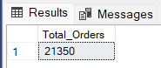

1. **Average Pizza’s per order:**

SELECT CAST(CAST(SUM(quantity) AS DECIMAL(10,2))/ CAST(COUNT(DISTINCT(order_id)) AS DECIMAL(10,2)) AS DECIMAL(10,2))

AS Avg_Pizza_Per_Order FROM pizza_sales

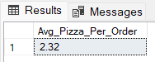

1. **Daily Trend for Total Orders:**

SELECT

DATENAME(DW,order_date) as Order_Day,

COUNT(DISTINCT(order_id)) AS Total_Orders from pizza_sales

GROUP BY DATENAME(DW,order_date)

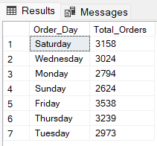

1. **Monthly Trend for Total Orders:**

SELECT

DATENAME(MONTH,order_date) as Order_Day,

COUNT(DISTINCT(order_id)) AS Total_Orders from pizza_sales

GROUP BY DATENAME(MONTH,order_date)

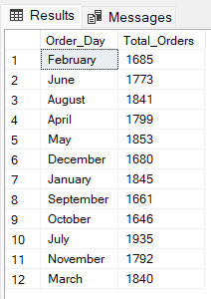

1. **Percentage of Sales by Pizza Category:**

SELECT pizza_category, SUM(total_price) as Total_Sales,

SUM(total_price) * 100 / (SELECT SUM(total_price) from pizza_sales) AS Percentage_Total_Sales

FROM pizza_sales

GROUP BY pizza_category

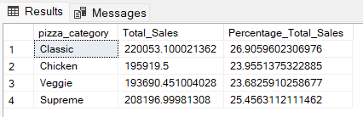

1. **Percentage of Sales by Pizza Size:**

SELECT pizza_size, SUM(total_price) as Total_Sales,

CAST(SUM(total_price) * 100 / (SELECT SUM(total_price) from pizza_sales) AS DECIMAL(10,2)) AS Percentage_Total_Sales

FROM pizza_sales

GROUP BY pizza_size

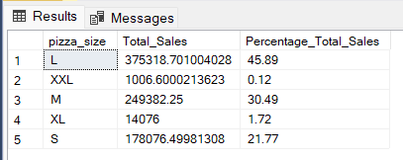

1. **Top 5 Pizzas by Revenue**

SELECT TOP 5 pizza_name, SUM(total_price) AS Total_Revenue FROM pizza_sales

GROUP BY pizza_name

ORDER BY Total_Revenue DESC

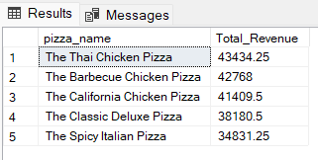

1. **Bottom 5 Pizzas by Revenue**

SELECT TOP 5 pizza_name, SUM(total_price) AS Total_Revenue FROM pizza_sales

GROUP BY pizza_name

ORDER BY Total_Revenue

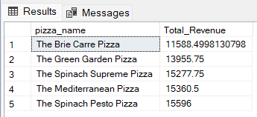

1. **Top 5 Pizzas by Quantity**

SELECT TOP 5 pizza_name, SUM(quantity) AS Total_Quantity FROM pizza_sales

GROUP BY pizza_name

ORDER BY Total_Quantity DESC

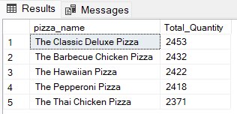

1. **Bottom 5 Pizzas by Quantity**

SELECT TOP 5 pizza_name, SUM(quantity) AS Total_Quantity FROM pizza_sales

GROUP BY pizza_name

ORDER BY Total_Quantity ASC

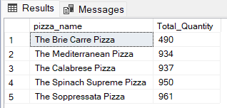

1. **Top 5 Pizzas by Total Orders**

SELECT TOP 5 pizza_name, COUNT(DISTINCT order_id) AS Total_Orders FROM pizza_sales

GROUP BY pizza_name

ORDER BY Total_Orders DESC

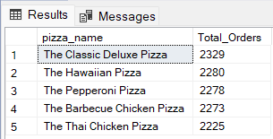

1. **Bottom 5 Pizzas by Total Orders**

SELECT TOP 5 pizza_name, COUNT(DISTINCT order_id) AS Total_Orders FROM pizza_sales

GROUP BY pizza_name

ORDER BY Total_Orders

